*Jahangirnagar University*

*Computer networking Lab*

*Lab report 7*



Course Title: Computer Networking laboratory

Course Code: CSE-402

Submitted by:

Name: Md. Omar Faruque Abir

Roll: 44

Submitted Date : 29-10-2019

**Name**: Implementation of OSPF (open shortest path first) Algorithm

**Introduction:**

**Open Shortest Path First** (**OSPF**) is a [routing protocol](https://en.wikipedia.org/wiki/Routing_protocol) for [Internet Protocol](https://en.wikipedia.org/wiki/Internet_Protocol) (IP) networks. It uses a [link state routing](https://en.wikipedia.org/wiki/Link-state_routing_protocol) (LSR) algorithm and falls into the group of [interior gateway protocols](https://en.wikipedia.org/wiki/Interior_gateway_protocol) (IGPs), operating within a single [autonomous system](https://en.wikipedia.org/wiki/Autonomous_system_(Internet)) (AS). It is defined as OSPF Version 2 in [RFC 2328](https://tools.ietf.org/html/rfc2328) (1998) for [IPv4](https://en.wikipedia.org/wiki/IPv4).[[1]](https://en.wikipedia.org/wiki/Open_Shortest_Path_First#cite_note-rfc2328-1) The updates for [IPv6](https://en.wikipedia.org/wiki/IPv6) are specified as OSPF Version 3 in [RFC 5340](https://tools.ietf.org/html/rfc5340) (2008). OSPF supports the [Classless Inter-Domain Routing](https://en.wikipedia.org/wiki/Classless_Inter-Domain_Routing) (CIDR) addressing model.

**Objective:**

We will simulate a network with 3 router with one pc connected with 3 router network and implement OSPF algorithm among these routers.

Add wic-2t after switching off router. Then turn on again.

**Network Layout:**

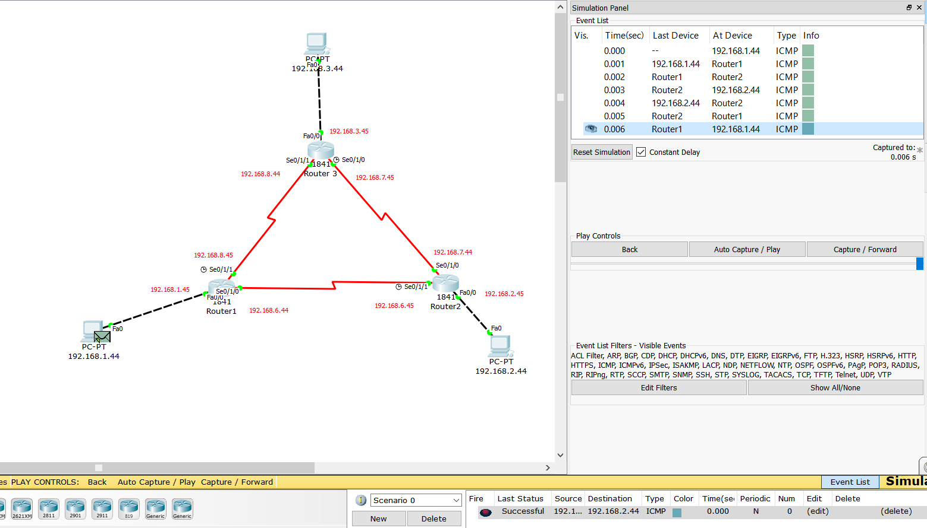

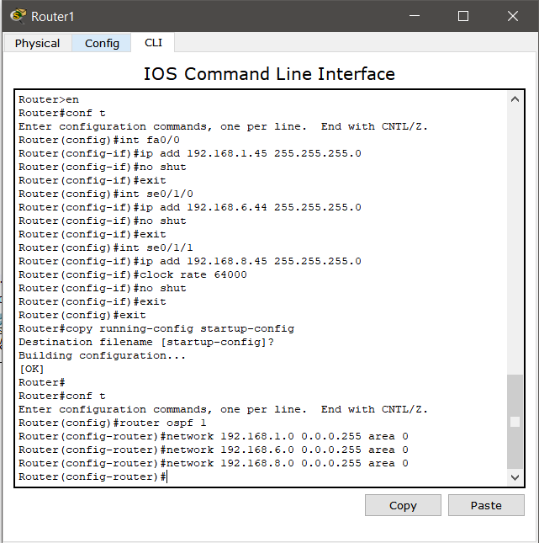

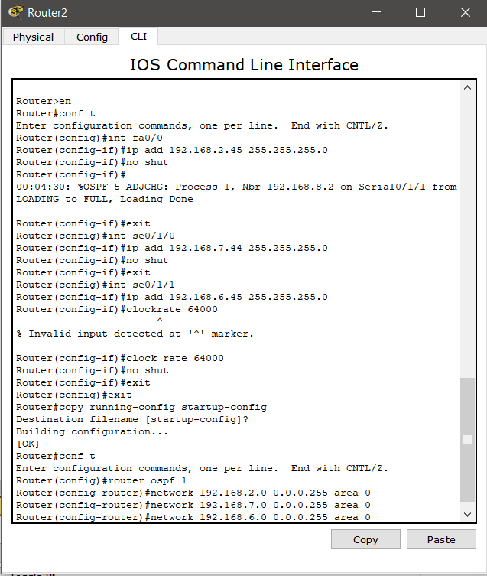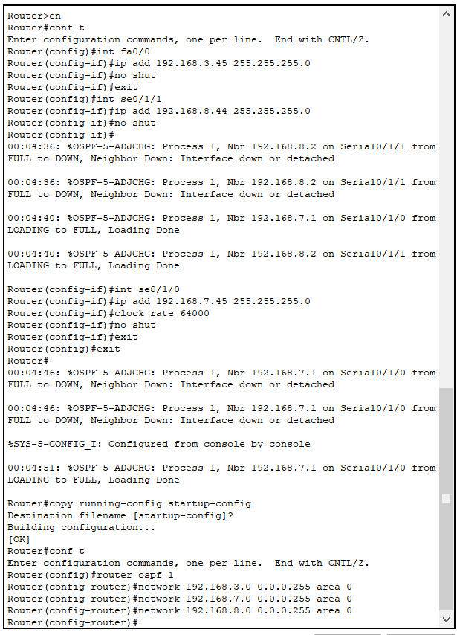

**Conclusion:**

We can clearly observe that providing different ip to the pc and different network to the router it is possible to transfer packet among them and construct a communication among them using ospf algorithm. So the experiment is valid.